PROJECT 1 : CREATION OF SINGLE PAGE WEBSTITE

ABSTRACTION

A single page application (SPA) is a web application that uses only one HTML web page as a shell for all the application's web pages and whose end-user interactions are implemented by using JavaScript, HTML, and CSS, bootstrap. Most of the SPA development is done on the front end as opposed to traditional web applications that rely heavily on web server interactions and that reload new web pages whenever navigation occurs. SPAs resemble native applications in their behavior and development but they run inside a browser process as opposed to native applications, which run in their own process. In order to understand why SPA development is so trendy today, we need to understand the changes that happened in the web environment that led to today's SPAs. In this chapter you will learn a little bit about web development history and reasons to build SPAs in the first place.

OBJECTIVE

The objective of this single page website is that users can learn about the company or website without having to navigate .this website helps the users to learn about 1stop.

Sometime ,having too many pages on website can overwhelm the user . they’re not easy to browse and can take long time to find exactly what you are looking for

.the main goal was that the project website to act as the core communication tool.it is to be simple and light ,more informative as possible, maintains easiness and content update

INTRODUCTION

Web development is the work involved in developing a website for the Internet (World Wide Web) or an intranet (a private network). The webpage developed can be both static and dynamic (using more complex languages such as CGI, AJAX, ASP, ASP.NET).

Static webpages are generally written in simpler languages such as HTML, JavaScript, CSS, etc. In our project we had developed a static web page with all basic functionalities included in it.

METHODOLOGY

Depending on the project, the front-end and back-end development can go either in parallel or the back-end is followed by the front-end. A front-end developer implements all visual features and makes sure everything is pixel-perfect, and that a website is cross-browser compatible.

Our project is all about developing a static webpage, so in out project we had no work much related to the back-end development.

Why create a static website?

Static websites are quick and easy to create.

It is cheap to host.

Static websites are secure.

It is fun and you can create awesome sites with HTML, CSS, and JavaScript

front-end development:

step 1: **Create the structure with HTML.**

HTML allows users to create and structure sections, headings, links, paragraphs, and more, on a website using various tags and elements. Almost everything you want to create on a web page can be done using a specific HTML code.

<!DOCTYPE html>

<html>  
<html lang=” en”>

<title>Page Title</title>  
<body>

<h1>This is your first header</h1>  
<p>This is paragraph text that pertains to your first header.</p>

<h2>This is your second header</h2>  
<p>This is paragraph text that pertains to your second header.</p>

<ul>  
<li>List</li>  
<li>List</li>  
<li>List</li>  
</ul>

<img src=”Image.jpg” alt=”Image-Alt-Text” style=”width:600px;height:450px”>

Click the link <a href= “https://learn.g2crowd.com/G2”>here</a> to be taken to the G2 Learning Hub.

</body>  
</html>

Step 2 :

**Style with CSS or Bootstrap:**

CSS is the language for describing the presentation of Web pages, including colors , layout, and fonts. It allows one to adapt the presentation to different types of devices, such as large screens, small screens, or printers.

As we know that CSS is a styling language while Bootstrap is a CSS framework. Much like how jQuery is a framework of JavaScript. Bootstrap might be easier to use because it has a comprehensive grid system with many elements already built so it saves up time .

Step 3:

**Make it interactive with JavaScript**.

JavaScript is a scripting language that enables you to create dynamically updating content, control multimedia, animate images, and pretty much everything else.

* **Code:**

<!DOCTYPE html>

<html lang="en">

<head> <meta charset="utf-8">

<title> Single page website |minor project</title>

<meta name="viewport" content="width-device-width, initial-scale-1"> <title>Single Page Website | Minor Project</title>

<link href="vendor/bootstrap/css/bootstrap.css" rel="stylesheet">

<link rel="stylesheet" href="https://cdnjs.cloudflare.com/ajax/libs/bootstrap-icons/1.10.4/font/bootstrap-icons.min.css" integrity="sha512-yU7+yXTc4VUanLSjkZq+buQN3afNA4j2ap/mxvdr440P5aW9np9vIr2JMZ2E5DuYeC9bAoH9CuCR7SJlXAa4pg==" crossorigin="anonymous" referrerpolicy="no-referrer" />">

<style>

.color-teal{

color: teal;

}

.icon-lg{

font: size 50px;

}

.icon-sm{

font: size 25px;

}

.remove-text-decoration{

text-decoration: none;

}

.remove-bullets{

list-style: none;

}

</style>

</head>

<body>

<header>

<nav class="navbar navbar-expand-lg navbar-light bg-light">

<div class="container-fluid">

<a href="#" class="navbar-brand">

<img src="asserts/logo.png" height="50" alt="Brand Logo">

</a>

<button type="button " class="navbar-toggler" data-bs-toggle="collapse" data-bs-target="#navbar">

<i class="bi bi-list"></i>

</button>

<div class="collapse navbar-collapse" id="navbar1">

<div class="navbar-nav ms-auto">

<a href="#" class="nav-item nav-link active"> Home</a>

<div class="nav-item dropdown">

<a href="#" class="nav-link dropdown-toggle" data-bs-toggle="dropdown">About us</a>

<div class="dropdown-menu">

<a href="#" class="dropdown-item">Company</a>

<a href="#" class="dropdown-item">Team</a>

</div>

</div>

<a href="#" class="nav-item nav-link" >Contact Us</a>

</div>

</div>

</div>

</nav>

<div id="carousel" class="carousel slide" data-bs-ride="carousel">

<div class="carousel-indicators">

<button type="button" data-bs-target="#carousel" data-bs-slide-to="0" class="active"></button>

<button type="button" data-bs-target="#carousel" data-bs-slide-to="1"></button>

<button type="button" data-bs-target="#carousel" data-bs-slide-to="2"></button>

</div>

<div class="carousel-inner">

<div class="carousel-item active">

<img src="https://dummyimage.com/600x400/000/fff" class="d-block w-100 " alt="Carousel 1" style="max-height: 100vh;">

</div>

<div class="carousel-item">

<img src="https://dummyimage.com/600x400/000/fff" class="d-block w-100 " alt="Carousel 2" style="max-height: 100vh;">

</div>

<div class="carousel-item">

<img src="https://dummyimage.com/600x400/000/fff" class="d-block w-100 " alt="Carousel 3" style="max-height: 100vh;">

</div>

</div>

<button class="carousel-control-prev" type="button" data-bs-target="#carousel" data-bs-slide-to="prev">

<span class="carousel-control-prev-icon"></span>

</button>

<button class="carousel-control-next" type="button" data-bs-target="#carousel" data-bs-slide-to="next">

<span class="carousel-control-next-icon"></span>

</button>

</div>

</header>

<main class="m-5">

<section class="container m-4" id="about-us">

<h6 class="display-6 text-center">About us</h6>

<div class="row">

<div class="col-md-5">

<div class="container">

<img src="https://dummyimage.com/600x400/000/fff" class="d-block w-100 " alt="Carousel 1" style="max-height: 100vh;">

</div>

</div>

<div class="col-md-7">

<p class="text-black-50">

An 'About Us' page is a spot for your founding story, a place to show off your business wins, and a sales page that answers the most pressing question new customers have about your business.

</p>

<p>An 'About Us' page is a spot for your founding story, a place to show off your business wins, and a sales page that answers the most pressing question new customers have about your business.

What an 'About Us' page should be is a goal-oriented sales page, one that focuses on highlighting the biggest selling points of your story and brand at the top of the page, making a strong first impression on curious customers

</p>

</div>

</div>

<div class="row">

<h6 class="display-6 text-center">What makes us unique</h6>

<div class="col-md-4">

<div class="container text-center">

<span class="bi bi-person color-teal icon-lg"></span>

<p> custom tailored user options</p>

</div>

</div>

<div class="col-md-4">

<div class="container text-center">

<span class="bi bi-shield-shaded color-teal icon-lg"></span>

<p> Privary First Apporach</p>

</div>

</div>

<div class="col-md-4">

<div class="container text-center">

<span class="bi bi-list color-teal icon-lg"></span>

<p> multiple variations</p>

</div>

</div>

</div>

</section>

<section id="team" class="container">

<h6 class="dispaly-5 text-center"> our innovative team</h6>

<div class="container">

<div class="row">

<div class="col-md-4 d-flex align-items-center justify-content-center">

<div class="card" style="width: 300px;">

<img class="card-img-top" src="https://dummyimage.com/600x400/000/fff&text=Sample+Image">

<div class="card-body text-center">

<h4 class="card-title"> Team member1</h4>

<p class="card-text">An 'About Us' page is a spot for your founding story.</p>

<i class="bi bi-facebook icon-sm-2"></i>

<i class="bi bi-instagram icon-sm-2"></i>

<i class="bi bi-linkedin icon-sm-2"></i>

</div>

</div>

</div>

<div class="col-md-4 d-flex align-items-center justify-content-center">

<div class="card" style="width: 300px;">

<img class="card-img-top" src="https://dummyimage.com/600x400/000/fff&text=Sample+Image">

<div class="card-body text-center">

<h4 class="card-title"> Team member1</h4>

<p class="card-text">An 'About Us' page is a spot for your founding story.</p>

<i class="bi bi-facebook icon-sm-2"></i>

<i class="bi bi-instagram icon-sm-2"></i>

<i class="bi bi-linkedin icon-sm-2"></i>

</div>

</div>

</div>

<div class="col-md-4 d-flex align-items-center justify-content-center">

<div class="card" style="width: 300px;">

<img class="card-img-top" src="https://dummyimage.com/600x400/000/fff&text=Sample+Image">

<div class="card-body text-center">

<h4 class="card-title"> Team member1</h4>

<p class="card-text">An 'About Us' page is a spot for your founding story.</p>

<i class="bi bi-facebook icon-sm-2"></i>

<i class="bi bi-instagram icon-sm-2"></i>

<i class="bi bi-linkedin icon-sm-2"></i>

</div>

</div>

</div>

</div>

</div>

</div>

</section>

<section id="contact" class="container">

<h6 class="display-6 text-center " > contact us</h6>

<div class="row">

<div class="col-md-6">

<div class="container p-3">

<p class="text-muted text-center fs-3"> here's our contaact info</p>

<div class="text-black-s text-center fd-4"> Our email</div>

<div class="text-black-50 text-center fs-5">support@example.com</div>

<div class="text-black-s text-center fd-4"> Our phone no.</div>

<div class="text-black-50 text-center fs-5">4569871230</div>

<div class="text-black-s text-center fd-4"> Our address</div>

<div class="text-black-50 text-center fs-5">some xyz city,state,country.</div>

</div>

</div>

<div class="col-md-6">

<div class="container">

<p class="text-muted text-center fs-3">you can also write to us</p>

<div class="container">

<div class="card shadow">

<div class="card-body">

<form>

<div class="form-group">

<label for="name" class="form-label"> Enter your Name</label>

<input type="text" class="form-control" name="name" id="name">

</div>

<div class="form-group">

<label for="email" class="form-label"> Enter your email</label>

<input type="email" class="form-control" name="email" id="emailid">

</div>

<div class="form-group">

<label for="subject" class="form-label"> Enter your subject</label>

<input type="text" class="form-control" name="subject" id="subject">

</div>

<div class="form-group">

<label for="message" class="form-label"> Enter your message</label>

<textarea class="form-control" name="message" id="message"></textarea>

</div>

<div class="form-group text-center" >

<input type="submit" class="btn btn-outline-dark" value="send message" >

</div>

</form>

</div>

</div>

</div>

</div>

</div>

</div>

</section>

</main>

<footer class="bg-dark">

<div class="container">

<div class="row">

<div class="col-md-6">

<div class="container">

<img src="asserts/logo.png" height="30px" class="bg-white">

<div>

<p class="text-white"> An 'About Us' page is a spot for your founding story, a place to show off your business wins, and a sales page that answers the most pressing question new customers have about your business. What an 'About Us' page should be is a goal-oriented sales page, one that focuses on highlighting the biggest selling points of your story and brand at the top of the page

, making a strong first impression on curious customers.</p>

</div>

</div>

</div>

<div class="col-md-6">

<div class="container">

<p class="text-white fs-5">Quick links</p>

<ul class="remove-bullets remove-text-decoration">

<li><a href="#" class="remove-text-decoration text-white"> About Us</a></li>

<li><a href="#" class="remove-text-decoration text-white"> Contact Us</a></li>

</ul>

</div>

</div>

</div>

<div class="row">

<div class="text-white text-center">

<p>all rights reserver &copy 2022,<a href="1stop.ai/"> 1stop.ai</a></p>

</div>

</div>

</div>

</footer>

<script src="https://code.jquery.com/jquery-3.6.4.js" integrity="sha256-a9jBBRygX1Bh5lt8GZjXDzyOB+bWve9EiO7tROUtj/E=" crossorigin="anonymous"></script>

<script src="https://cdnjs.cloudflare.com/ajax/libs/popper.js/2.9.2/umd/popper.min.js" integrity="sha512-2rNj2KJ+D8s1ceNasTIex6z4HWyOnEYLVC3FigGOmyQCZc2eBXKgOxQmo3oKLHyfcj53uz4QMsRCWNbLd32Q1g==" crossorigin="anonymous" referrerpolicy="no-referrer"></script>

<script src="vendor/bootstrap/js/bootstrap.js"> </script>

</body>

</html>

OUTPUT

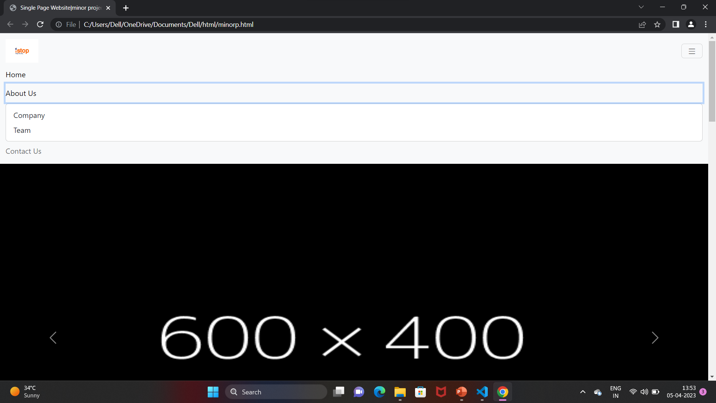

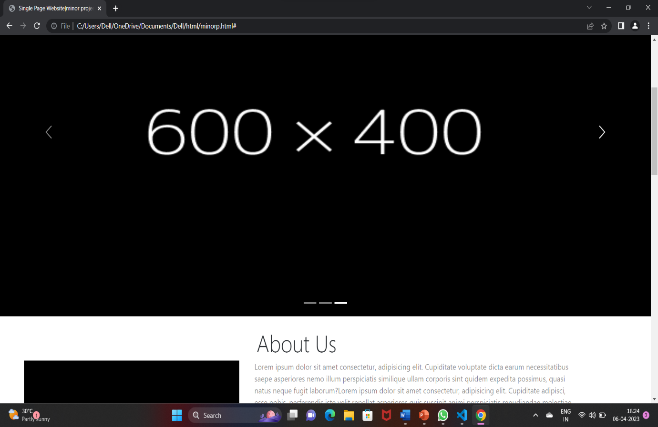

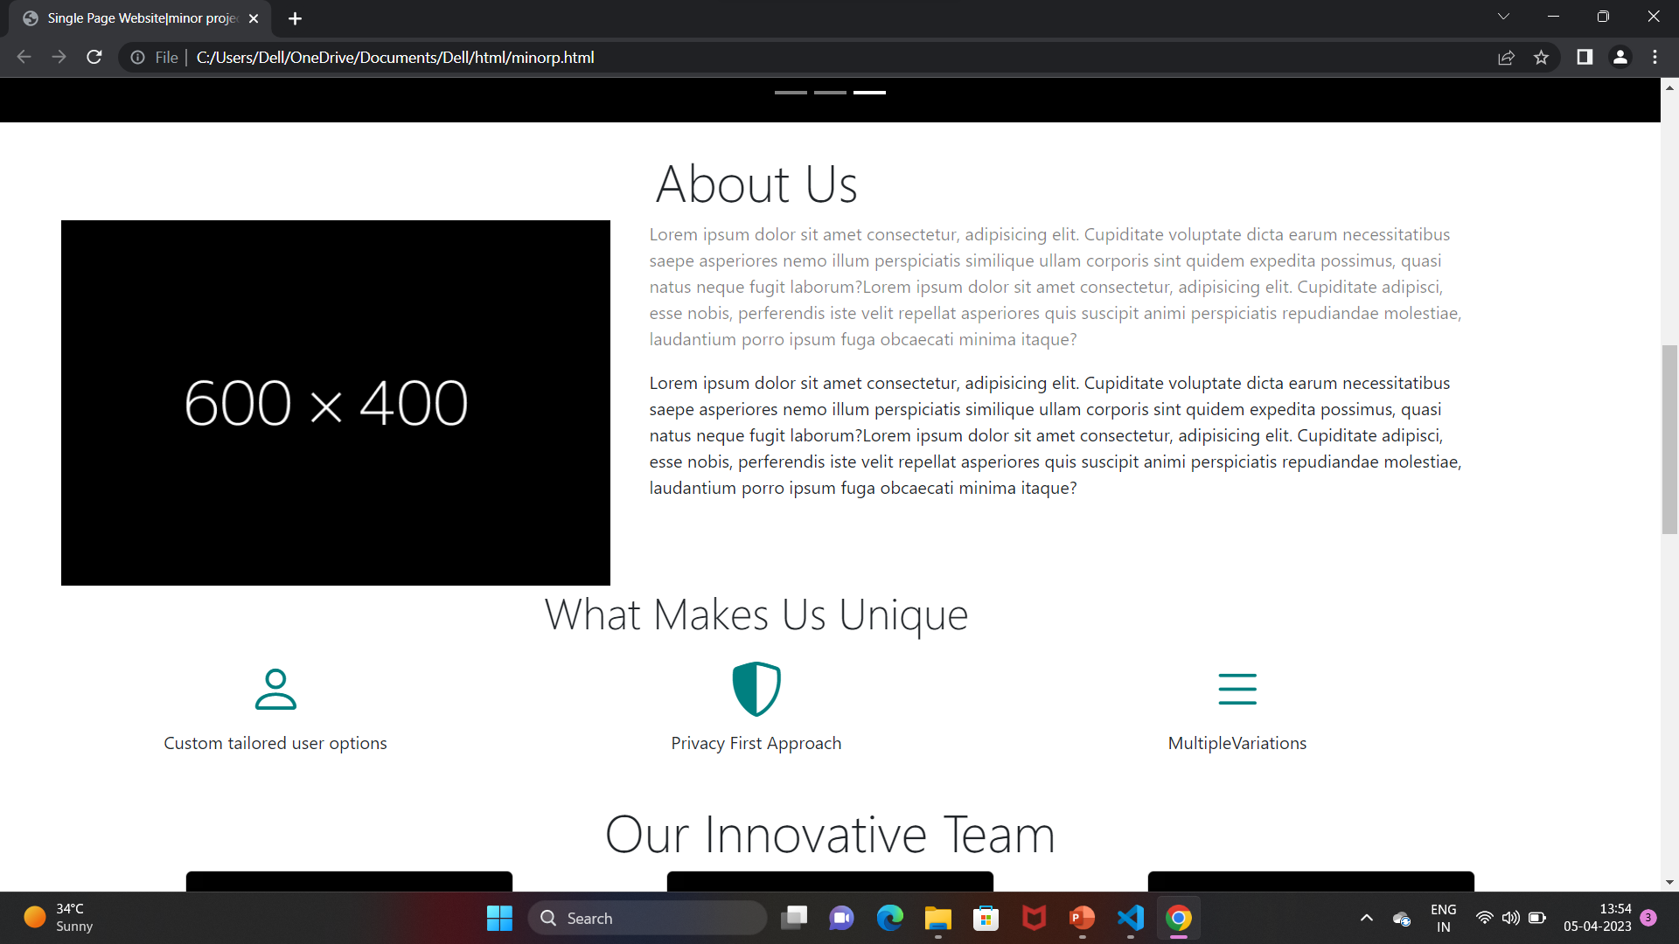

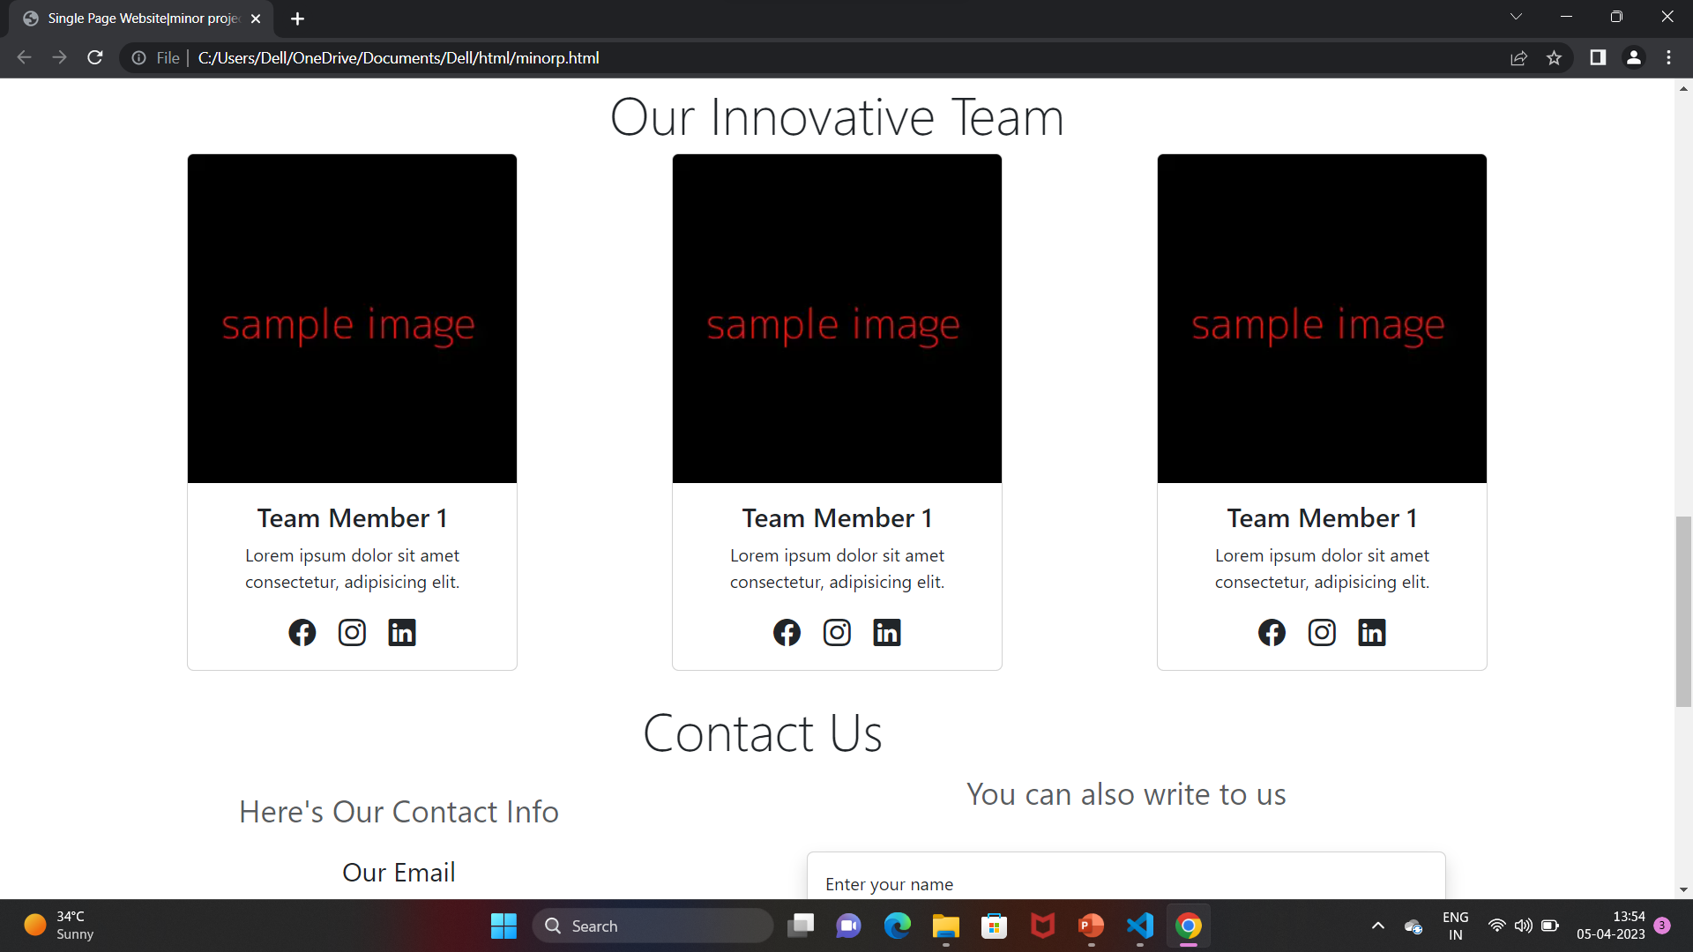

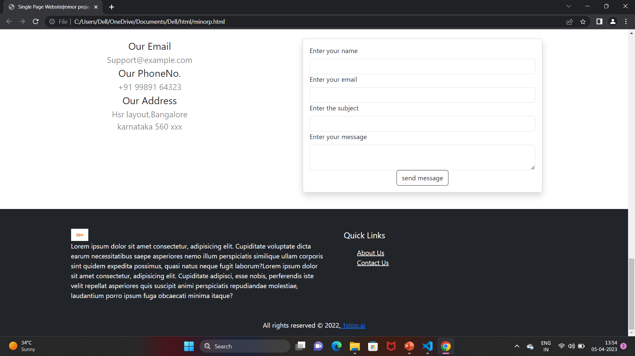

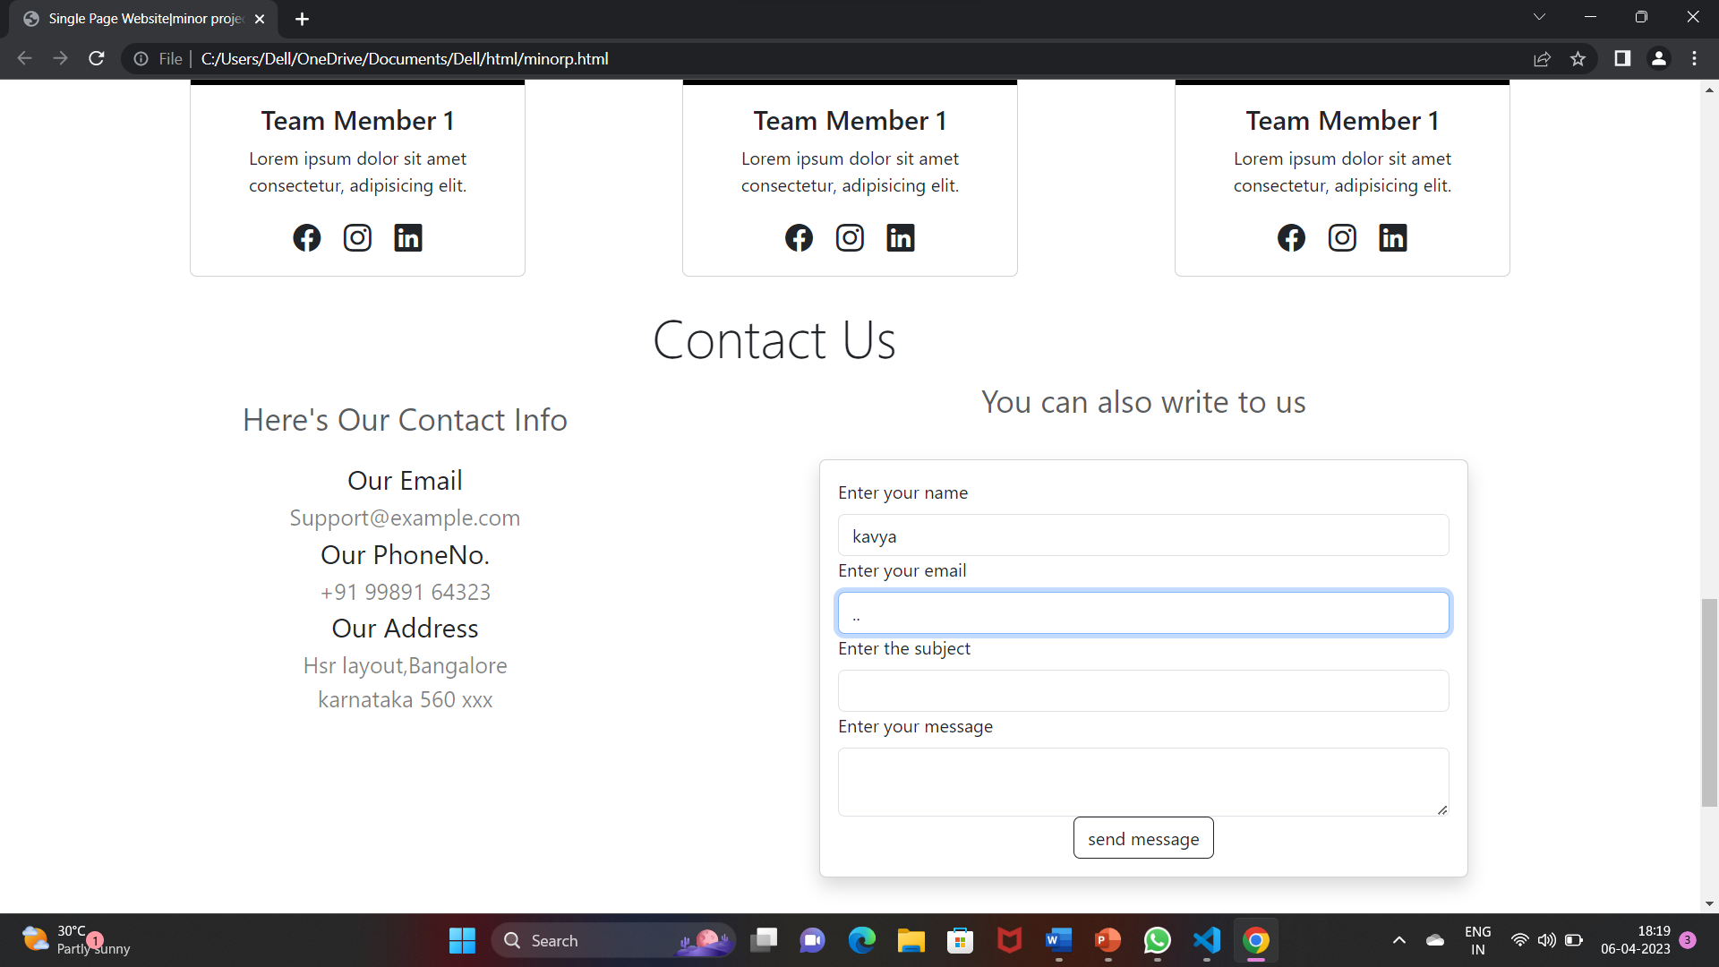

CONCLUSION

The purpose and objective of single page website is achieved . Web page designing is easy and in an aesthetic form.

Flexibility in designing makes user explore their imagination.

The user can learn information about the particular website without having to navigate to other web pages ,which is easy to users.